**CSC 365 Assignment 3**

Net profit graph traversal

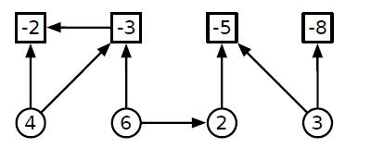

**Student**: Jimmy Nguyen **T,TH** 12:45 PM – 2:05 PM

**Idea**:

A general concept used was splitting a set into unique subsets. I first found how to get the bell number of a set but wanted a list of every subset which was really a list of a list. I then created a list of sets that was in a list (list of list). Each list is iterated through and has a net (profit + cost). At the end of the subset and net calculations, a comparison is made so that we can determine which list/subset is the most profitable (via net). Dependencies are accounted for and the net must be >= 0 for the task to be performed, otherwise it will yield an empty set.

|  |  |  |  |
| --- | --- | --- | --- |
| Test Files |  |  |  |
| Yielding Results: | [A, B, C]  profit=12  cost=-10  net=2 | [B, C],  profit=6  cost=-2  net=4 | []  Don’t perform the task as it nets to negative value. |

Notice that the test files can have a line break to separate the project and expense nodes.